2015 Clear The Air Challenge

FACEBOOK

Promoted Posts

Post #1
Start your team of coworkers, family or neighbors and bring on the Challenge. #ShowUCAIR by driving less and driving smarter and you will help improve Utah’s air quality and conserve energy.

2015 Clear The Air Challenge
The Clear the Air Challenge is a month long competition starting July 1st that gives you the chance to reduce your vehicle emissions by choosing alternative methods of transportation using TravelWise strategies.
Link: https://goo.gl/5eOv37 (shortened unique URL for tracking)

Post #2
Reduce your emissions during the month-long Clear The Air Challenge starting July 1st. By parking your car just one day a week, vehicle emissions would be reduced by 6,500 tons a year. Who will you challenge? #ShowUCAIR
2015 Clear The Air Challenge
The Clear the Air Challenge is a month long competition starting July 1st that gives you the chance to reduce your vehicle emissions by choosing alternative methods of transportation using TravelWise strategies.
Link: https://goo.gl/9lt0Pv (shortened unique URL for tracking)
Post #3
Challenge your neighbors, coworkers or family to improve air quality in Utah. You could win the coveted Challenge trophy or other cool prizes by implementing TravelWise strategies in July. #ShowUCAIR
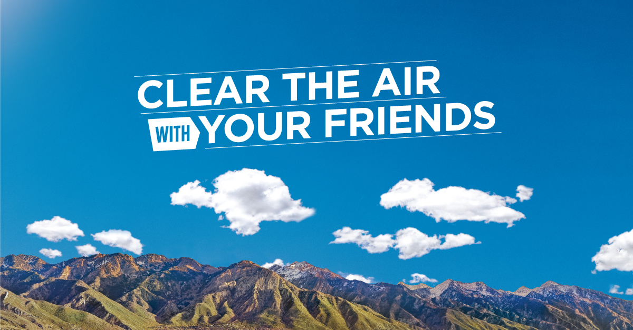
2015 Clear The Air Challenge
The Clear the Air Challenge is a month long competition starting July 1st that gives you the chance to reduce your vehicle emissions by choosing alternative methods of transportation using TravelWise strategies.
Link: https://goo.gl/Iglwlb (shortened unique URL for tracking)

Post #4
Help improve air quality in Utah by driving less and driving smarter. #ShowUCAIR by taking the Clear the Air Challenge. Sign up your team before July 1st.
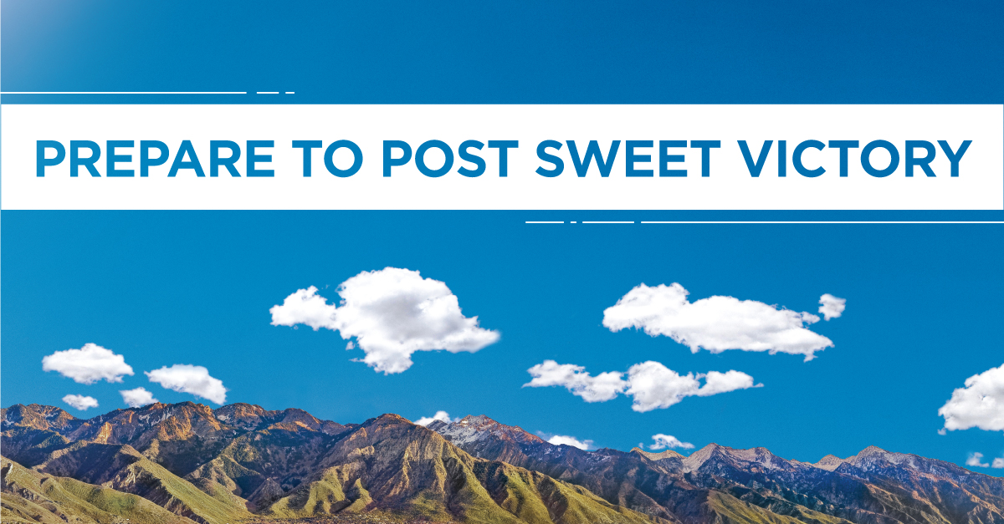
2015 Clear The Air Challenge
The Clear the Air Challenge is a month long competition starting July 1st that gives you the chance to reduce your vehicle emissions by choosing alternative methods of transportation using TravelWise strategies.
Link: https://goo.gl/bPNwfC (shortened unique URL for tracking)

Post #5
The Clear the Air Challenge, hosted by UCAIR, TravelWise, and the Salt Lake Chamber, starts July 1st. This is your chance to #ShowUCAIR by driving less and driving smarter. Start your team today!
2015 Clear The Air Challenge
The Clear the Air Challenge is a month long competition starting July 1st that gives you the chance to reduce your vehicle emissions by choosing alternative methods of transportation using TravelWise strategies.
Link: https://goo.gl/CgBYHp (shortened unique URL for tracking)

TWITTER

Promoted Tweets

Tweet #1
Show you care about Utah’s air. Improve air quality by taking the Clear the Air Challenge and win amazing prizes. #ShowUCAIR https://cards.twitter.com/cards/18ce53wsvvm/kpfv

Tweet #2
Help us improve air quality in Utah by using TravelWise strategies during the Clear the Air Challenge. #ShowUCAIR https://cards.twitter.com/cards/18ce53wsvvm/kpfv

Link: https://goo.gl/vw7rW3
Lead Cards (example tweets)

